DEVOPS
ASSIGNMENT 1
Installation of Nginx.
Task Description:
This task involves creating a Jenkins Freestyle job that automates the installation of Nginx on an Ubuntu server using the command sudo apt-get install -y nginx. This automation ensures consistent server setup and can be easily repeated, making it ideal for automated environments.

Steps:
- Update Package List:
  - Run the following command to update the package list:
  - sudo apt update
- Install Nginx:
  - Install Nginx using the following command:
  - sudo apt-get install -y nginx
- Verify Installation:
  - Check if Nginx is running with the command:
  - systemctl status nginx
- Create Jenkins Freestyle Job:
  - In Jenkins, click New Item and create a Freestyle project (e.g., Install_Nginx).
- Configure Job:
  - Add a build step of type Execute shell.
  - In the shell command box, enter:
  - sudo apt update
  - sudo apt-get install -y nginx
- Save and Run Job:
  - Save the job and click Build Now to run it.

- Check Console Output:
  - After the job completes, view the Console Output to confirm the successful installation of Nginx.

OUTPUT:

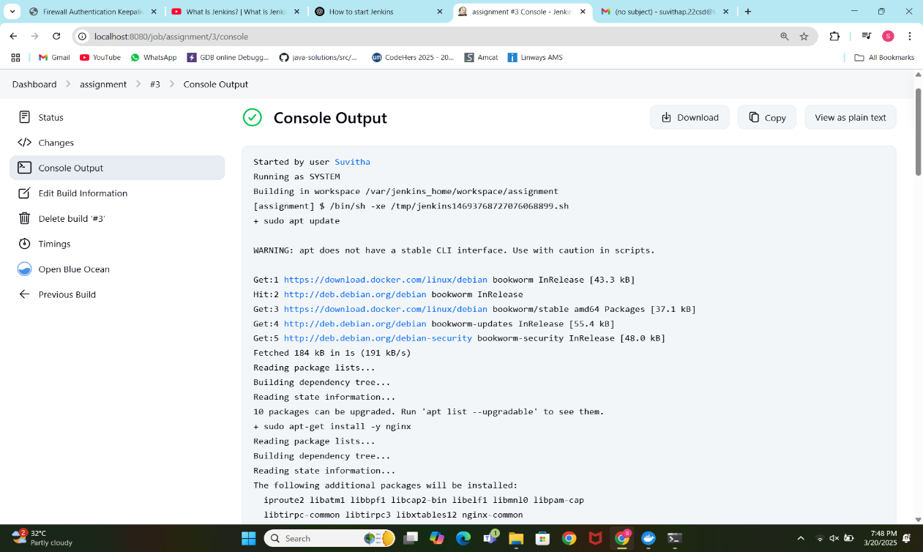

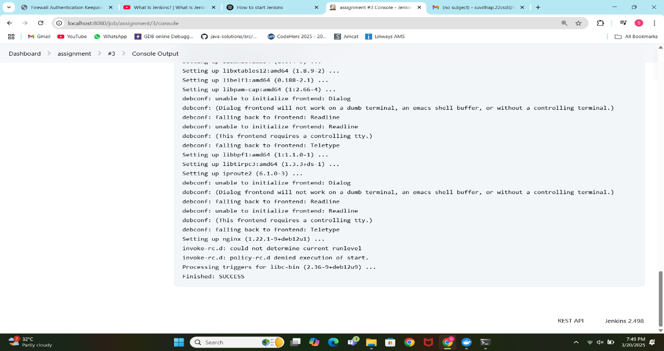
ASSIGNMENT 2
CI/CD Pipeline Setup Using Jenkins
Task Description:
This task involves setting up a Continuous Integration and Continuous Deployment (CI/CD) pipeline using Jenkins to automate the build, test, and push process of a containerized web application. The pipeline integrates GitHub for source code management, Docker for containerization, and a container registry (such as Docker Hub) for storing the container image.

Steps to Set Up the CI/CD Pipeline:
- Install Jenkins:
  - Ensure Jenkins is running and install necessary plugins (Git, Docker).
- Create a New Pipeline Job:
  - Create a new Pipeline job in Jenkins to automate the build, test, and deployment process.
- Configure the GitHub Repository:
  - Link your GitHub repository to Jenkins to automatically pull the latest code.
- Write the Pipeline Script (Jenkinsfile):
  - Define stages in the Jenkinsfile:
    - Clone Repository: Pull the latest code from GitHub.
    - Build Docker Image: Build the image using Docker.
    - Push Docker Image: Push the image to a container registry (e.g., Docker Hub).
- Add Docker Credentials (if needed):
  - Add Docker credentials to Jenkins if using a private registry for authentication.
- Trigger the Pipeline:
  - Trigger the pipeline manually or set up GitHub webhooks for automatic triggers on code changes.

OUTPUT:
